AI / Non-AI Collaboration Log – Task-Based Template
Complete one log for each major milestone of your project (min. 4 logs total).
Maximum 2 logs per week. Each log should take ~10–15 minutes.
Choose and fill either Path A (AI) or Path B (Non-AI) for each milestone and omit the other, depending on what you used.

Milestone Categories (choose one for each log)
- Planning & Research – defining goals, gathering requirements, outlining scope.
- Design & Architecture – creating structure, workflows, and initial prototypes.
- Core Development – building main features, core functionality, and foundational systems.
- Integration – connecting components, services, or data sources.
- Quality Assurance – testing, debugging, and refining functionality.
- Optimization – improving performance, usability, and efficiency.
- Finalization & Delivery – polishing, documentation, deployment, and handoff.

Log Entry # __2
Milestone Category: _________design and architecture__________
Date / Week: ____12/4/2025_______________
Commit ID / Screenshot link: 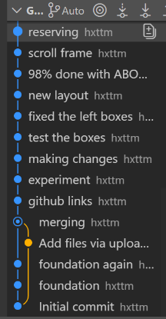01f1b95bb15ec74c3e3ed8da1049bc690251383b

Path A – If you used AI
- Task Description
(1–2 sentences about what you worked on)
Example: “Integrated the weather API and displayed results in a card layout.”

- AI Input
(Paste 1 AI prompt + 1 snippet of AI output, Share your AI conversations with the share button, share the entire history of the AI chat not the response only.)

- My Edit / Change
(1–2 sentences: What you modified, why, or what you learned)
Example: “AI didn’t handle API errors. I added try/catch to manage missing data.”

- Reflection Prompt (choose one / add your own)
  - What mistake did AI make, and how did you spot it?
  - What did AI do better/faster than you?
  - What unique decision did you add that AI couldn’t?
  - How would you explain this feature to a non-coder in 2 sentences?

Path B – If you did not use AI
- Task Description
(1–2 sentences about what you worked on)
Example: “Created responsive navbar with media queries.”
Designed the colours and fonts.

- Support Source Used
(Document what helped you: docs, tutorials, peers, debugging)
Example: “I used MDN docs on flexbox and StackOverflow for media query syntax.”
I used google fonts to choose the fonts.

- My Edit / Change
(1–2 sentences: What you modified, why, or what you learned)
Example: “The tutorial used px units, I switched to rem units for accessibility.”
I bold some words.

- Reflection Prompt (choose one / add your own)
  - What mistake or confusion did you find in the resource, and how did you resolve it?
  - What did the resource help you do more quickly?
  - What unique decision or creativity did you add that wasn’t in the resource?
  - How would you explain this feature to a non-coder in 2 sentences?

What I found confusing was how to import the font into the html. I didn’t believe it was imported as when I typed “font: ” they didn’t have the font I wanted. But I just had to save and see the live server, and it was updated!!

